Data Story

Xiyu Zhang

In recent years, electric vehicle sales are continually breaking records. According to a recent International Energy Agency (IEA) report, one in every seven passenger cars bought globally in 2022 was an EV. Electric vehicles (EVs) are generally seen as vital to decarbonize road transport. However, despite the strong increase in the sales of electric vehicles, it is not enough to offset the emissions from conventional fleets, mainly from hot-selling sports utility vehicles (SUVs), according to a project of IEA. Time is limited, and the window for reaching the goal of net zero is closing quickly. It is urgent to accelerate the deployment of electric and zero-emission vehicles.

In the past decades, plenty of supportive investments and policies have been implied in key markets to stimulate the sale of EVs, and many of them were proven efficient. The United States market is no exception. Among the most noteworthy and most recent policies accelerating EVs in the US is the National Electric Vehicle Infrastructure (NEVI) Formula Program, authorized under the Bipartisan Infrastructure Law (BIL), aiming to build a nationwide network of 500,000 electric vehicle charging stations (EVCS) by 2030. It is widely believed that the more EV charging posts are built, the more people will be motivated to buy EVs. Many stories in the news media match this inherent impression. “More people want to buy an electric car, but they have concerns about power,” reported by WYPR News, John Lee, demonstrating the impediment for Maryland to move to all electric vehicle sales is people’s worries about being powerless. This state has an ambition that only electric vehicles will be sold in the state by 2035.

However, some most updated data of 2021 tell a different story.

We sought to examine the relationship between the growth of electric vehicles in each state in 2021 and the density of electric vehicle charging plugs in each state's charging facilities. The following figure shows two regressions based on two scatter plots. There are two widely used definitions of “density of electric vehicle charging plugs”, also called chargers, in relative literature. One calculates the number of EV charging plugs per unit area, and the other calculates the local average number of EV charging plugs per registered electric vehicle.

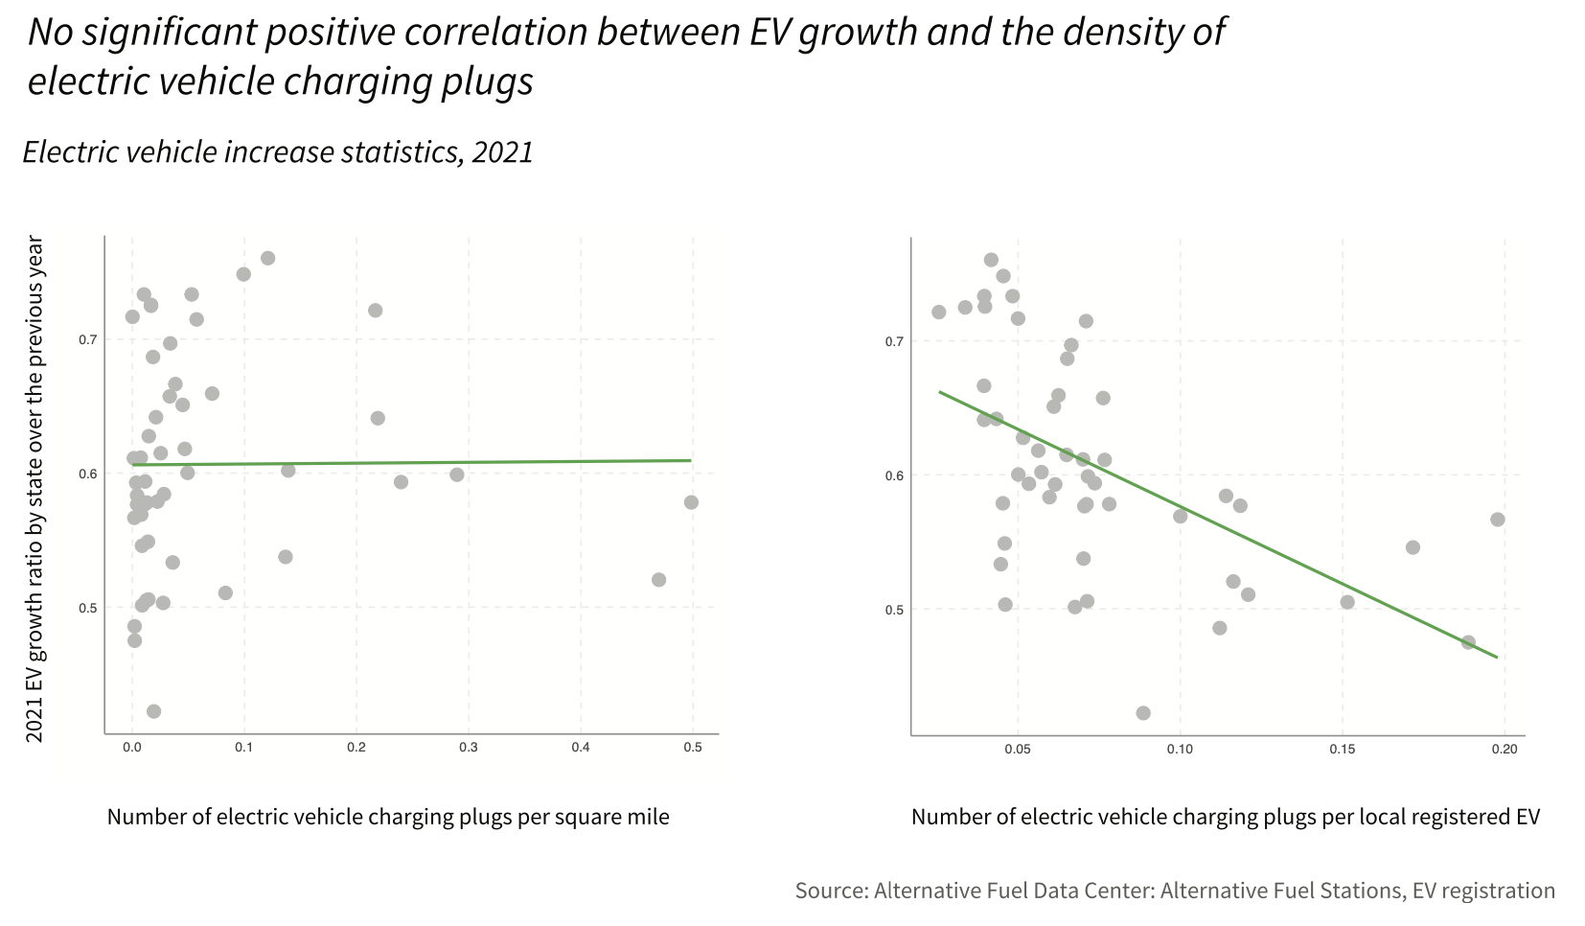

In fact, numerous factors influence a resident's decision to choose an electric vehicle over a conventional one. Merely expanding the number of electric vehicle chargers available may not necessarily stimulate the sale of electric vehicles. The demographics of the local population, the travel characteristics of the local population, and policy scenarios are just as important as the ease of access to EV charging stations in determining EV sales.

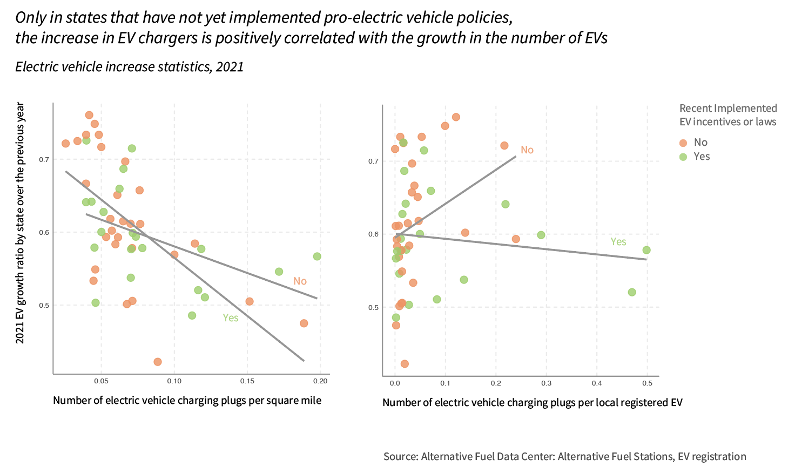

John, L. (2023, May 8). Some are powerless to buy an electric car as Maryland moves to all EV sales. *WYPR*. https://www.wypr.org/wypr-news/2023-05-08/some-are-powerless-to-buy-an-electric-car-as-maryland-moves-to-all-ev-sales